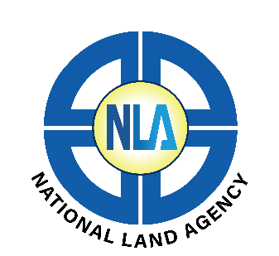

Applications are invited for suitable qualified candidates to fill the following positions within the INFORMATION & COMMUNICATION TECHNOLOGY DIVISION at the National Land Agency.

Systems Architect
(VACANT)

This position reports to the Senior Application Developer.

Job Purpose

To strategically design and implement in house information systems and network software architecture that support core functions and assure their high availability and to improve internal processes through software implementation, diagnostic and maintenance strategies.

Key Responsibilities:

Management/Administrative Responsibilities
- Assists with the design and delivery of technical training programmes
- Makes recommendations on matters relating to data management and conversion

Technical /Professional Responsibilities
- Assists in assigned information systems projects from planning through to implementation and adoption
- Assists in the development and maintenance of manuals, procedures and other documentation required for the operations of the support team
- Assists in developing tactical plans that support agency-wide strategies for application integration and business data relationships
- Recommends commercially available information technologies or designs customized solutions to satisfy business needs
- Assists with projects and initiatives with a focus on meeting strategic business objectives
- Coordinates with business unit and technical staff on the defining, writing and testing of technical and functional specifications
- Resolves end-user problems or issues regarding business applications, web applications and provides application administrative support
- Coordinates the installation of application patches, releases and enhancements on development, test, disaster recovery and production systems
- Participate in the review of existing procedures and updates as is necessary to improve the effectiveness the operations
- Develops documents and maintains procedures for production and quality control of system data
- Configures, updates, modifies, maintains and effect improvements on the Agency’s Intranet and external web site
- Coordinates the routine backup and restoration of the configurations, files and folders and databases of the Agency’s Intranet and external web site
- Develops user-friendly tools that aids in the management of data

Other Responsibilities
- Keeps abreast of trends and developments in information technology and recommends their incorporation where appropriate
- Performs other related duties assigned from time to time by the Supervisor.

Required Skills/ Competencies
The post-holder should be able to demonstrate:
- Ability to establish business requirements documents as well as testing plans and training plans and materials
- Software programming skills ideally in various languages
- Use of software development standards, structured development environments and methodologies
- Knowledge of service oriented architecture concepts, reporting tools and standard programming environments
- Strong technical documentation, problem solving and analytical skills
- Working knowledge of Microsoft Office Tools
- Excellent technical, interpersonal and customer relationship skills and ability to thrive in a team-based environment
- Understanding of business processes
- Excellent business modeling skills
- Ability to conduct structured interviews to gather process and system information
- Strong data modeling skills;
- Good oral and written communication skills
- Good conflict resolution skills

Minimum Required Qualifications and Experience:
The following qualification is required:
- BSc in Computer Studies or equivalent qualification
- Two (2) years’ experience developing and maintaining business applications across the system lifecycle
- Experience and knowledge of current reporting tools
- Specific working experience in a MS Visual Studio development environment

Remuneration Package: - Salary Range: $ 3,501,526.00 - $ 4,709,163.00 p.a.

A letter of application accompanied by a Résumé should be submitted no later than

Friday, August 15, 2025 to jobapplications@nla.gov.jm for the attention of:
The Director, Human Resource Management & Development
National Land Agency
8 Ardenne Road
Kingston 10
We appreciate all responses, but only shortlisted applicants will be contacted.

